02.07
STRUCTURAL DAMAGE
Process Design & AMOS Configuration Document
Purpose
This Process Design document is provided to Key-Users to record their key decisions regarding the AMOS Process design and the required AMOS configuration.
It is updated throughout the Project Definition Phase and used as the baseline for the Final Acceptance prior to Go-Live
Revision
Author, Name | Date | Notes
Swiss-AS Consulting | 02.06.2024 | Draft

Table of Contents
1. Process Overview & Objectives 3
2. Regulatory References 3
3. Definitions & Glossary 3
4. Process Tasks 3
5. Process Dependencies 3
6. Process Flow 4
7. Process Design Questions 5
8. Data (Source) Mapping 6
9. Other Software Used 6
10. AMOS Configuration 7
a. Basic Data 7
b. Parameters 7
c. Workflows 7
d. Scheduled Tasks 7
e. API’s & Interfaces 7
11. UAT Guidance 8
12. Annex – Additional Info 8

Process Overview & Objectives

Process General Description:
Record and track the Structural Damage entries of aircraft and of components.

Main Process Objective (Outputs & Outcomes):
The structural damage and repair record enables aircraft operators to record, review, view, and track all damage that occurs in an aircraft structure to ensure the safety of the aircraft's operations.
Structural damage of an aircraft includes dents, scratches, cracks, and buckles. The damage to an aircraft is typically discovered by a visual inspection but can also be discovered because of impaired flight performance. Each aircraft manufacturer distributes and maintains a structural repair manual (SRM) that details the damage types, limitations, and standard repair plans. Damage that is not covered within the SRM requires a specific repair plan to be created by the manufacturer or their designated design authority. You can use the structural damage and repair record to support the process of recording structural damage, in the user interface, and through an interactive graphical representation of an aircraft.

Regulatory References
- FAA 14 CFR Part 26 Subpart E Aging Airplane Safety – Damage Tolerance Data for Repairs and Alterations
- FAA 14 CFR Part 21.370a Aging Airplane Inspections and Records Reviews
- FAA 14 CFR Part 25.571 Damage-Tolerance and Fatigue Evaluation of Structure
- FAA 14 CFR Part 91.1505 Repair Assessment for Pressurized fuselages
- FAA 14 CFR Part 121.1105 Aging Airplane Inspections and Records Reviews
- FAA 14 CFR Part 121.1107 Repairs assessment for pressurized fuselages
- FAA 14 CFR Part 135.422 Aging airplane inspections and records reviews for multiengine airplanes certificated with nine or fewer passenger seats.
- FAA AC 91-56B - Continuing Structural Integrity Program for Large Transport Category Airplanes
- FAA AC 120-93 - Damage Tolerance Inspections for Repairs
- FAA Order 8300.12 - Aging Airplane Program
- FAA Order 8300.13 - Repair Assessment Program
- EASA Part 21 Subpart D Repairs and Modifications
- EASA CS-25 Appendix H Instructions for Continued Airworthiness
- CS 25.571 - Damage-Tolerance and Fatigue Evaluation of Structure
- EASA Part 145 Maintenance Organization Approvals
- EASA Part M Subpart C Continuing Airworthiness Requirements
- Commission Regulation (EU) No 1321/2014 - Continuing Airworthiness
- EASA Safety Information Bulletin (SIB) 2012-09R1 - Aging Aircraft Structures
- EASA AMC 20-20 - Continuing Structural Integrity Programme
- EASA AMC 25.1529 and GM 25.1529 - Instructions for Continued Airworthiness

Definitions & Glossary

Key-Words | Explanation
STR | Single Running Taskcard
AdHoc JIC | AdHoc JICs are repetitive plannable events that can be created from the Mechanics or Engineering to follow nonstandard requirements. Their behavior is like an SRT, without having the needs to enter new temporary taskcards in the maintenance program.
SRM | Structural Repair Manual. A maintenance manual issued by a manufacturer and approved by the Authority that describes, in detail, specific repairs that are approved for a particular aircraft structure.

Process Tasks

Business Process Task / Actions / Activities:
- Create structural damage entry
- Manage structural damage entry
- Print out structural damage report

Process Dependencies

Input | Concurrent | Output
08.02 Performing Maintenance (Structural Damage Finding) |  | 01.04 SB & AD Assessment  (Generate Document)
02.01 Aircraft Phase-In  (Existing Structural Damage Item) |  | 02.09 Airworthiness Certificate (Mod Status Report)

Process Flow

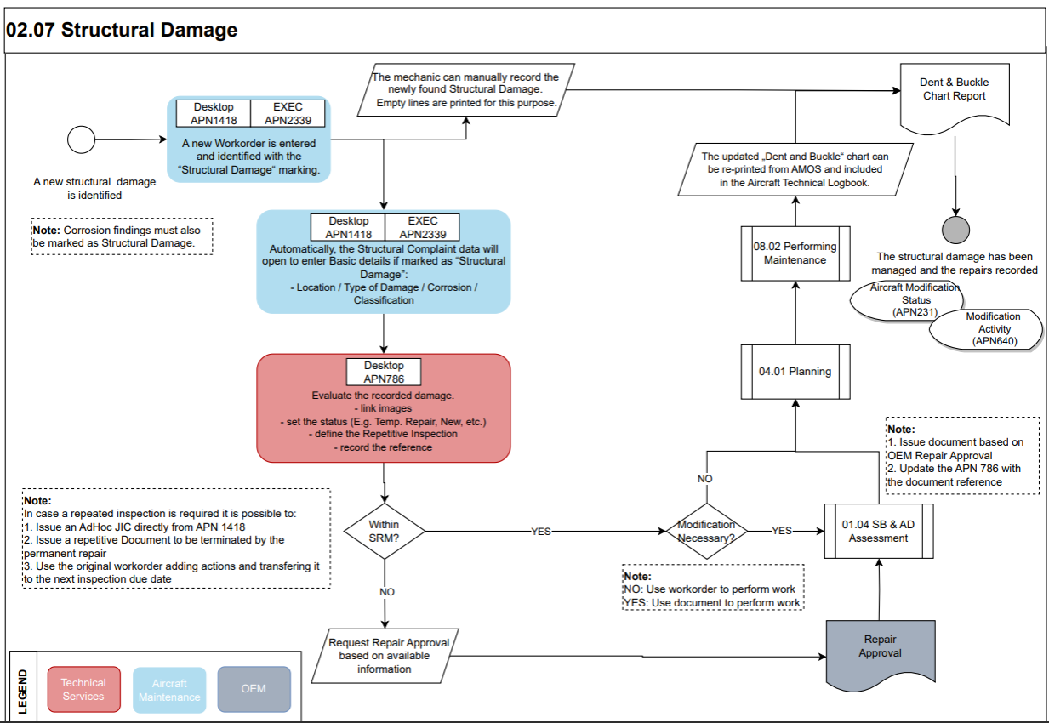

Process Design Questions

# | Question | Answer
1 | Who in your organization currently identifies findings as being Structural Damage Items? Mech, Inspector, MCC, Engineer, etc.
2 | Who measures and evaluates the damage?
3 | Who contacts the OEM of damages are outside SRM limits? MCC, Engineering on duty, etc.?
4 | How do you handle Component Damage such as Fan Blades or Flaps? On a specific damage chart?
5 | Do you track damages on a D&B chart?
7 | Do you placard your dents and damage items?
8 | How do you manage Temp repairs?

Data (Source) Mapping

Data Sources | Description | Volume / Manual / Automatic / Static / Dynamic
- | - | -

Other Software Used

Other Softwares | Used by: | Description
- | - | -

AMOS Configuration

Structural Damage Charts:
For aircraft charts they are defined in Aircraft Administration (APN 308) in the images tab. The charts can be created for specific aircraft registration, type, subtype, and/or model. This is also true for components; the chart should be added to the Part definition (APN 59) under the “Images” Tab.
Form Configuration:
Customize Structural Damage Program utilizing AMOS Form Configuration (APN1444) using Form Config ID 786 “Structural Damage Form Config”, set mandatory and default values, mark unnecessary fields as hidden or set validation rules.

Basic Data

Basic Data Table | Notes
Damage Status | Every damage has status according the status the damage entry is displayed with the according color code.
Nature of Damage | Every damage can be classified by the nature of damage.
Type of Damage | Every damage is classified by the type of damage.
Direction | Directions, e.g. used to describe structural damages

Parameters

Parameter Code | Parameter Name | Notes
- | - | - | -

Workflows

Workflow Number | Workflow Name | Notes
72 | General Structural Damage Workflow | This workflow is triggered when:  Structural Damage item is deleted, a new item is saved, After Closing a Structural damage item, when print the report, and when a component with Damage item is removed from the aircraft

Scheduled Tasks

Scheduled Task Reference | Frequency | Notes
AircraftStatusReportExport | Weekly
StructuralDamageRecreateItemNo | Once/ On Demand

API’s & Interfaces

Reference | Direction | Trigger | Frequency
TRANSFER STRUCTURAL DAMAGE | Export |  | Depends
EXPORT STRUCTURAL DAMAGE | Export/Import |  | Depends

UAT Guidance

# | Sample Test-Cases to be considered
T02.07.01 | Create structural damage entry
T02.07.02 | Manage structural damage entry
T02.07.03 | Print out structural damage report

Annex – Additional Info

Defining a Structural damage in AMOS
Structural Damage is used to display data about damages on an aircraft or parts. To have a better overview, Structural Damage gives you the opportunity to pinpoint on the Dent & Buckle Chart, where each damage item exists. A table displays an overview of all damages of this aircraft or part.
- All features apply to both aircraft and part damages.
- One workorder can have several damages but one damage can only have one main workorder.
- As soon as a damage with a repetitive inspection is created, an Ad-hoc JIC can only be created directly from Structural Damage if the Workorder No. field is filled with a linked workorder.
- Part damages can be displayed on an aircraft chart and the damage follows the part when it is installed on a different aircraft.
AMOS allows five different options to visually classify a damage in APN786:
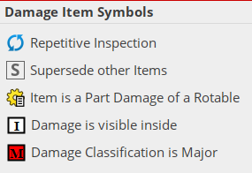
A Workorder must be entered and be identified with the “Structural Damage” marking. Automatically, the Structural Complaint data will open to enter details:
- Location
- Type of Damage
- Corrosion
- Classification
Please note: additional data tab allows to add additional information related to:
- Defective Part
- Inspection method used
- Corrosion
This information can be used for filtering purposes and are reflected in the Single Damage Report.
A structural damage can be manually recorded on the Structural Damage APN 786 report (Empty lines at the end of the report are printed for this purpose).
Evaluation of the Damage
Engineering department should be informed about new damages to evaluate the recorded damage. Best practice is open a technical query directly from the originating workorder.
It is also possible to set up Workflow ID:72 to inform relevant people once a new Structural Damage has been entered.
The Engineer can as well:
- Link images
- Set the status (Temp. Repair)

- Define the Repetitive Inspection choosing one of the following options:
Repetitive Inspection:
by uncontrolled interval | Select if repetitive inspections are required for this damage using an uncontrolled interval. Enter the value in the field and select the radio button for the dimension:  H = Flight Hours; D = Calendar Days; C = Flight Cycles; Others. If Others, enter a description of the interval dimension.
by document reference | Select if repetitive inspections are required for this damage using a document reference. Select from the drop-down list.
Last Performed | Date the last repetitive inspection was performed.
Next Due | Date the next repetitive inspection is due.
- Record the reference
After the evaluation the decision must be taken if the damage is within the SRM limitations or not. Please note SRM, as well as other OEM documents, can be imported in AMOS using OEM Documents Management APN 1524 and visualized using OEM Documents Library APN 1525.
If outside the SRM limitations, the approval request must be triggered to the OEM to receive a detailed approved repair instruction.

Repetitive Inspections:
There are four different ways to control repetitive inspections:
- Extension of the original issues workorder by the applicable interval according to SRM or OEM approval.
- Issuing of an Adhoc-JIC with the applicable interval according to the SRM or OEM approval
NOTE: Use the AD HOC JIC, the related Program must be activated in APN 249
In this case defer the original WO to the final repair, once the final repair has been performed, deactivate manually the Adhoc-JIC (from APN 1895) and close the WO. The final repair will be done with the original workorder.
- Issuing of a document (e.g., EO) with the applicable interval according to the SRM or OEM approval
In this case, define a document in APN 63 for the final repair that terminates the document defined for the repetitive inspection. Once the final repair document will be closed, the repetitive document gets terminated (by the terminated functionality in APN 63). The original workorder can be closed and a reference entry for the document should be entered into APN 768.
- Issuing of taskcard in the maintenance program with the applicable interval according to the SRM or OEM approval
In this case the original workorder will be transferred to the final repair date (if available) and the repetitive inspection can be incorporated in the maintenance program. Once the final repair has been performed the taskcard can be deactivated.
NOTE: Some authorities might for additional approval for each revision of the maintenance programs

Corrosion Findings tracking:
- Corrosion Prevention & Control Programs (CPCP): Workstep classification available

Two possible reports can be generated in Structural Damage APN 786:
- Structural Damage Report: Dent & Buckle Chart and Repair Details
- Single Damage Report: Details of the single entry
Please note: The reports generated are based on the results of search criteria. Use the filtering options to get the desired report (e.g., get only the repair entries).

